Math I Mrs. Orr Name: _______________________

Unit 2: One-Variable Statistics

|  |  |  |  |
| --- | --- | --- | --- |
| **Day** | **Date** | **Topic** | **Grade**  **Teacher fills in** |
| **A DAY** |
| 1 | Monday,  Oct. 5 | **Shapes** of Graphs: Frequency Tables, Histograms, Dot Plots  **PRACTICE:** #1 |  |
| 2 | Wednesday,  Oct. 7  **PLAN** | Box-Plots and the 5-Number Summary  Calculating **Outliers**  **PRACTICE:** # 2 |  |
| 3 | Friday,  Oct. 9 | **Work on Project** |  |
| 4 | Tuesday,  Oct. 13 | **QUIZ**  Measures of **Center**: Mean and Median  **PRACTICE:** #3 - 4 |  |
| 5 | Thursday,  Oct. 15 | Measures of **Spread**: IQR and  Standard Deviation  **PRACTICE**: #5  *Project Due tomorrow.* |  |
| 6 | Monday,  Oct. 19 | **PROJECT DUE TODAY**  (This packet will be collected today!) |  |

Come to **tutoring** on

TUESDAYS & THURSDAYS

2:30 – 3:45 pm

WEBSITE: [**www.calculatORR.weebly.com**](http://www.calculatORR.weebly.com)

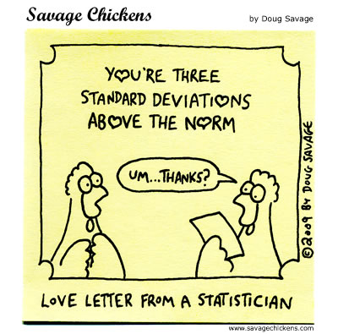

**Go to Broughton’s Math 1 page for tutorials and extra practice!**

**http://bhsccmath.weebly.com/**

**Unit 2 STANDARDS**

**Quantities (not tested separately)**

**Reason quantitatively and use units to solve problems.**

**N-Q.1** ~~Use units as a way to understand problems and to guide the solution of multi-step problems; choose and interpret units consistently in formulas;~~ choose and interpret the scale and the origin in graphs and data displays.

**N-Q.2** Define appropriate quantities for the purpose of descriptive modeling.

**N-Q.3** Choose a level of accuracy appropriate to limitations on measurement when reporting quantities.

**Interpreting Categorical and Quantitative Data★**

**Summarize, represent, and interpret data on a single count or measurement variable.**

**SKILL 5: I can REPRESENT ONE-VARIABLE STATISTICAL DATA multiple ways.**

**S-ID.1** Represent data with plots on the real number line (dot plots, histograms, and box plots).

**SKILL 6: I can COMPARE ONE-VARIABLE STATISTICAL DATA.**

**S-ID.2** Use statistics appropriate to the shape of the data distribution to compare center (median, mean) and spread (interquartile range, standard deviation) of two or more different data sets.

**SKILL 7: I can INTERPRET ONE-VARIABLE STATISTICAL DATA.**

**S-ID.3** Interpret differences in shape, center, and spread in the context of the data sets, accounting for possible effects of extreme data points (outliers).

**UNIT 2 PRACTICE**

**DAY 1 Practice (Skill 6)**

1. The two distributions below show the highest and lowest temperatures on record at 289 major US weather-observing stations in all 50 states, Puerto Rico, and the Pacific Islands.

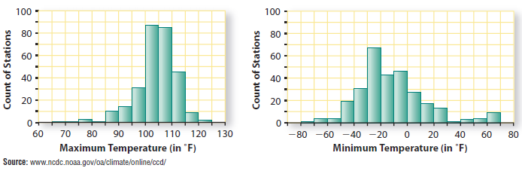**MAX TEMP MIN TEMP**

a. About how many stations had a record **minimum** temperature from $-40℉$ up to $-30℉$? __________

About how many had a record **maximum** temperature less than $90℉$? ____________

What percentage of **maximum** temperatures are above 115 $℉$? _____________

b. Describe the shapes of the two distributions.

What might account for the cluster in the tail on the right side of the distributions of minimum temperatures?

c. Without computing, estimate the mean and median in each distribution.

MAX TEMP: MIN TEMP:

MEAN: _____ MEAN: _____

MEDIAN: ______ MEDIAN: ______

d. Which distribution has a greater spread of temperatures? Explain how you came to his conclusion.

**DAY 2 Practice (Skill 5 and Skill 6)**

|  |  |  |  |
| --- | --- | --- | --- |
| **Michael Jordan** | | **Lebron James** | |
| **Season** | **Points Scored** | **Season** | **Points Scored** |
| 84 -85 | 2313 | 03 – 04 | 1654 |
| 85 -86 | 408 | 04 – 05 | 2175 |
| 86 - 87 | 3041 | 05 – 06 | 2478 |
| 87 - 88 | 2868 | 06 – 07 | 2132 |
| 88 - 89 | 2633 | 07 – 08 | 2250 |
| 89 - 90 | 2753 | 08 – 09 | 2304 |
| 90 - 91 | 2580 | 09 – 10 | 2258 |
| 91 - 92 | 2404 | 10 - 11 | 2111 |

1. The table below shows the total points scored during the first 8 seasons for Michael Jordan and Lebron James.

a. Find the 5-number summary (min, Q1, median, Q3, max) for each player.

Michael Jordan: Lebron James:

b. Show the calculations for finding outlier 1.5(IQR) rule for each player.

Michael Jordan: Lebron James:

Outlier: ______ Outlier: _______

c. Make a Stacked Box Plot for each player:

Michael Jordan

Lebron James

d. Based on statistics alone, who would you rather have on your team. Why?

**DAY 4 Practice (Skill 6 and Skill 7)**

1. C:\Program Files\Microsoft Office\MEDIA\CAGCAT10\j0183168.wmf The football team had a fundraiser and the coach gladly announced that the average (or the mean) of sales for each football player was approximately $90. Now look at the data of the football players’ fundraiser sales below. When you check the coach’s math, he was telling the truth – the average (or the mean) is $87.50, but why is this not an accurate representation of the data?

|  |
| --- |
| $ in fundraiser sales |
| 20 |
| 40 |
| 40 |
| 60 |
| 20 |
| 400 |
| 80 |
| 40 |

1. Circle the outlier.
2. Calculate the median.
3. Compare the median and the mean ($87.50).

Should the coach have used the median instead of the mean? Why?

1. Examine the distribution of the number of pennies stacked using their dominant hand by students in Ms. Smith’s first period class.
2. How many students were in the first-period class?
3. What percentage of students stacked more than 40 pennies using their dominant hand?
4. If a student turned her data in late, and she stacked 36 pennies, how would that change our graph?
5. Where would you guess the center of the graph is?
6. What do you think the plot for the second period class might look like? Explain.

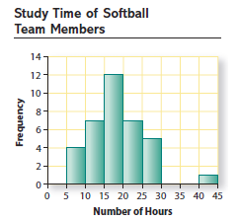 **DAY 5 Practice (Skill 6 and Skill 7)**

1. All 36 members of the Caledonia softball team reported

the number of hours they study in a typical week.

The numbers are given below.

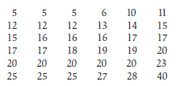

a. Describe the shape of the graph.

b. Using the data, calculate the mean and standard deviation. (you can use your calculator)

c. Akemi is the student who studies 40 hours per week and is considering quitting the team to focus on school. How will the mean and standard deviation change if Akemi quits the team?

d. The softball coach expects the team to practice 10 hours per week. If practice hours are added to weekly study hours, how will the center and spread change?