Math I Mrs. Orr Name: _______________________

Unit 1: Equations and Inequalities

|  |  |  |  |
| --- | --- | --- | --- |
| **Day** | **Date** | **Topic** | **Grade**  **(Teacher fills in)** |
| **A DAY** |
| 1 | Wednesday Aug. 26 | Solving Equations  **PRACTICE**: #1 – 5 |  |
| 2 | Friday, Aug. 28 | Solving Equations  **PRACTICE:** #6 – 10 |  |
| 3 | Tuesday Sept. 1 | Solving Equations  **PRACTICE:** #11 – 15 |  |
| 4 | Thursday, Sept. 3 | Solving Inequalities  **PRACTICE**: #16 – 20 |  |
| 5 | Tuesday, Sept. 8 | Solving Inequalities  **PRACTICE**: #21 - 25 |  |
| 6 | Thursday Sept. 10 | **QUIZ TODAY**, Formulas  **PRACTICE:** #26 – 27 |  |
| 7 | Monday Sept. 14 | Formulas  **PRACTICE:** #28 - 30 |  |
| 8 | Wednesday, Sept. 16 | Area and Volume Formulas  **PRACTICE**: #31 – 35 |  |
| 9 | Friday, Sept. 18 | Points, Shapes, and Midpoints  **PRACTICE:** #36 – 38 |  |
| 10 | Tuesday, Sep. 30 | Pythagorean Thm and Distance Form.  **PRACTICE:** #39 – 43 |  |
| 11 | Friday, Sept. 25 | Perimeters and Areas Using Distance  **PRACTICE**: #44 - 45 |  |
| 12 | Tuesday, Sept. 29 | Review Day |  |
| 13 | Thursday, Oct. 1 | **TEST TODAY** | (This sheet will be collected today!) |

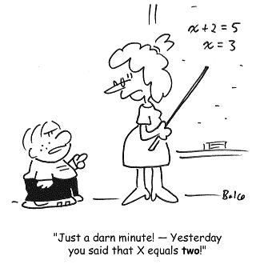

Come to **tutoring** on

TUESDAYS & THURSDAYS

2:30 – 3:30 pm

WEBSITE: **www.calculatORR.weebly.com**

**Unit 1 Skills & Standards**

**Quantities (not assessed separately)**

**N-Q.1** Use units as a way to understand problems and to guide the solution of multi-step problems; choose and interpret units consistently in formulas; choose and interpret the scale and the origin in graphs and data displays.

**N-Q.3** Choose a level of accuracy appropriate to limitations on measurement when reporting quantities.

**Seeing Structure in Expressions (not assessed separately)**

**A-SSE.1** Interpret expressions that represent a quantity in terms of its context.

1. Interpret parts of an expression, such as terms, factors, and coefficients.

**SKILL 1: I can SOLVE EQUATIONS and INEQUALITIES and EXPLAIN EACH STEP.**

**A-REI.1** Explain each step in solving a simple equation as following from the equality of numbers asserted at the previous step, starting from the assumption that the original equation has a solution. Construct a viable argument to justify a solution method.

**A-REI.3** Solve linear equations and inequalities in one variable, including equations with coefficients represented by letters.

**SKILL 2: I can CREATE EQUATIONS and INEQUALITIES.**

**A-CED.1** Create equations and inequalities in one variable and use them to solve problems. Include equations arising from linear ~~and quadratic functions, and simple rational and exponential~~ functions.

**SKILL 3: I can USE FORMULAS TO SOLVE PROBLEMS.**

**G-GMD.1** Give an informal argument for the formulas for the circumference of a circle, area of a circle, volume of a cylinder, pyramid, and cone. Use dissection arguments, Cavalieri’s principle, and ~~informal limit arguments~~.

**G-GMD.3** Use volume formulas for cylinders, pyramids, cones, and spheres to solve problems. ★

**SKILL 4: I can USE FORMULAS TO FIND PERIMETERS AND AREAS.**

**G-GPE.7** Use coordinates to compute perimeters of polygons and areas of triangles and rectangles, e.g., using the distance formula.

**8.G.6** Explain a proof of the Pythagorean Theorem and its converse.

**8.G.7** Apply the Pythagorean Theorem to determine unknown side lengths in right triangles in real-world and mathematical problems in two and three dimensions.

**8.G.8** Apply the Pythagorean Theorem to find the distance between two points in a coordinate system.

**UNIT 1 PRACTICE**

**DAY 1 Practice (Skill 1)**

**Writing and Simplifying Algebraic Expressions:** Write each phrase as an algebraic expression.

1. A cab fare is $2 flat fee plus $0.50 per mile *m* _________________________________

2. Gary is taking golf lessons that each cost *x* dollars. In the first week, he spent $50 on golf shoes and took two lessons. The next week he took three lessons and won $20 for making a hole in one. Create an expression for the COST of the two weeks combined and then simplify it.

_________________________________

**Solving Equations**: 3 PART PROBLEM: SOLVE, REASON, AND CHECK! Solve each equation while writing a justification for each step (such as “Distribute”, “Combine like Terms”, etc.) and check your answer.

3. 3*x* + 7 = 8 4. 5. If 2*x* + 4 = –6, what does 2 – 3*x* equal?

(*hint: solve for x in the first equation first!)*

**DAY 2 Practice (Skill 1 and Skill 2)**

**Solving Equations**: 3 PART PROBLEM: SOLVE, REASON, AND CHECK! Solve each equation while writing a justification for each step (such as “Distribute”, “Combine like Terms”, etc.) and check your answer.

6. 7. 2.3*x* + *x* – 6 = 1.5 8. 112 = 7*x* + 7(–4*x* – 17)

**Creating Equations:** Define a variable and write an equation. Do NOT solve.

9. Trevor is a salesperson who is paid a salary of $500 plus 2% commission. Write and solve an equation to determine how much Trevor must sell to earn $2,000 this month.

10. Daniel Davis Dillard is proud of the lawn care business he runs after school. He charges a flat rate of $10 plus $2 per quarter acre of lawn. After mowing Mr. Stafford’s lawn 5 times, he made a total of $122. Write and solve an equation to determine how many acres of lawn Mr. Stafford has.

**DAY 3 Practice (Skill 1 and Skill 2)**

**Solving Equations**: 3 PART PROBLEM: SOLVE, REASON, AND CHECK! Solve each equation while writing a justification for each step (such as “Distribute”, “Combine like Terms”, etc.) and check your answer.

11. 4*y +* 15 = 6*y –* 11 12**.** 6*q –* 1 = –*q +* 20

13. 4*x* + 2.5 = -28.4 – 2.2*x* 14. –2(–*w +* 11) = –13 + 2*w –* 9

**Creating Equations:** Define a variable, write an equation and SOLVE.

15. Suzanne is going to rent a car while she is out of town. One car rental company offers a flat rate of $35 per day plus $0.10 per mile. Another car rental company offers the same car for $25 per day plus $0.25 per mile. She will need the car for 5 days. How many miles would she need to drive for the first rental company to be the better deal?

**DAY 4 Practice (Skill 1)**

**Solving Inequalities: (** *Don’t forget to flip the sign when appropriate!)*

*Solve each inequality. Match the solution to the graph.*

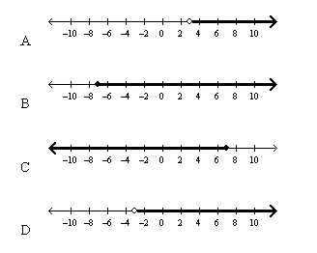

*_______* 16. $-8≥x-15$_______ 17. $4x+3<5x$

_______ 18. $8x>7x-3$_______ 19. $x-2≥-9$

*Solve the inequality. Graph your solution on a number line.*

20. $\frac{d}{2}-1>3$

**DAY 5 Practice (Skill 1 and Skill 2)**

**Solving Inequalities: (** *Don’t forget to flip the sign when appropriate!)*

*Solve each inequality. Graph your solution on a number line.*

21. 22. 



*Define a variable. Set up an inequality and solve.*

23. The low temperatures for the previous two days were 62º and 58º. What would the temperature need to be for the third day such that the average daily temperature is at least 64º.

24. The freight elevator of a building can safely carry a load of at most 4000 lb. A worker needs to move supplies in 50-lb boxes from the loading dock to the fourth floor of the building. The worker weighs 160 lb. The cart used to transport the boxes weighs 95 lb. What is the maximum number of boxes that can be transported at one time using the elevator?

*Show work or explain your answer.*

25. What is the solution to this inequality? 

**DAY 6 Practice (Skill 1 and Skill 3)**

**Formulas (Literal Equations):**

26.*Match the formulas with their shapes. Shapes can be used more than once.*

_______ I. $A=πr^{2}$ A.

_______ II. $a^{2}+b^{2}=c^{2}$

_______ III. $A=\frac{1}{2}bh$ B.

_______ IV.

_______ V. C.

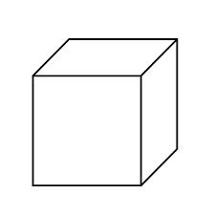_______ VI.

D.

27. The perimeter of a rectangle is *P* = 2*l* + 2*w* where *P* is the perimeter, *l* is the length, and *w* is the width. Solve the formula for *w*.

**DAY 7 Practice (Skill 1 and Skill 3 and Skill 4)**

**Formulas (Literal Equations)**

1. 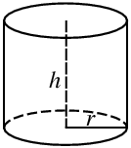**Volume of a Cylinder** . A cylinder is a 3D shape with two circular bases. To find the volume (how much a cylinder can hold), you find the area one of the circular bases and multiply by the height. The formula looks this: ***V* = π*r*2*h*** where *V* is the volume, *r* is the radius, and *h* is the height.

a. What is the volume of a cylinder with a radius of 4 cm. and a height of 11 cm.? Round to the nearest hundredth place.

b. What if we wanted to know more about the height of the cylinder? Solve the formula above for *h.*

1. Can you solve the original formula for *r*? Try it!

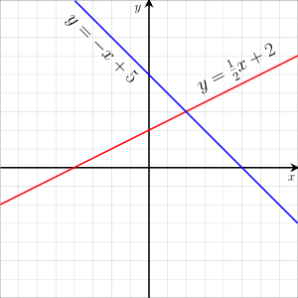29. **Equation of a Line.** The slope-intercept form of an equation is *y* = m*x* + b. Put the following in slope intercept equation – in other words, solve for the variable *y*:

a.) 3*x* – 2*y* = 10 b.) ½*y* + 5*x* = 10

1. 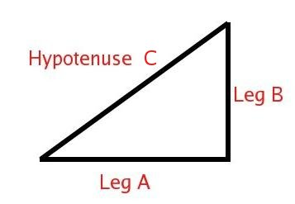 **Pythagorean Theorem.** The Greek mathematician, Pythagoras, found that in any right-angled triangle, the [hypotenuse](http://en.wikipedia.org/wiki/Hypotenuse) (the side opposite the right angle) is equal to the sum of the two legs squared. The formula is often written *a*2 + *b*2 = *c*2 where *a* and *b* are the legs and *c* is the hypotenuse.
2. Solve the Pythagorean theorem for leg *a*.
3. Using your answer in part (a), leg *b* = 6 cm and the hypotenuse *c* = 10 cm, how long is leg *a*?

**DAY 8 Practice (Skill 1 and Skill 3)**

**Area and Volume Formulas**

1. 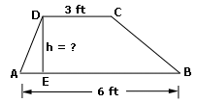 If a trapezoid below has an area of 36 ft.2, find the height. The area of a trapezoid is *A* = ½ (*b*1 + *b*2)*h* where *b*1 is base 1, *b*2 is base 2 and *h* is the height, find the height of this trapezoid.

1.  Gears on a bicycle are just circles in shape. One gear has a diameter of 4”, and a smaller one has a diameter of 2”. How much bigger is the area of the larger one compared to the smaller one?
2. 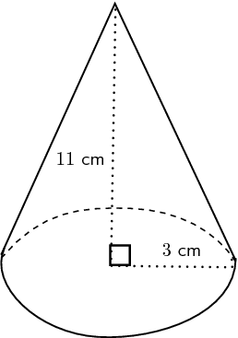The volume of a cone is found by using the formula: $V=\frac{1}{3}πr^{2}h$ where *r* is the radius and *h* is the height. Find the volume of the cone pictured on the below:
3. C:\Users\sprofio-miller\AppData\Local\Microsoft\Windows\Temporary Internet Files\Content.IE5\GUIWDC5F\MM900283633[1].gifA rectangular box has a volume of 41.791 in3. If the length and width are equal and the height is 7.9 inches, find the length and width.
4. C:\Users\sprofio-miller\AppData\Local\Microsoft\Windows\Temporary Internet Files\Content.IE5\9CUNS3JO\MC900048285[1].wmf The volume of a sphere is $V=\frac{4}{3}πr^{3}$. Find the volume given a radius of 8 cm.

**DAY 9 Practice (Skill 4)**

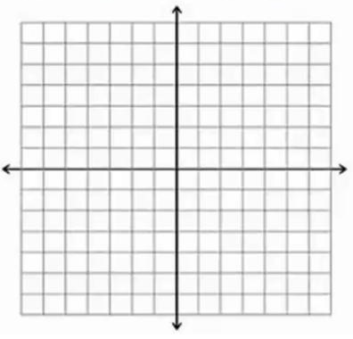36.Graph the points on the coordinate plane given on the right, connect the point to create a shape, and answer the following questions: A **(5, 1) B (-2, 1) C (-2, 4) D(5, 4)**

1. What shape does it make? ______________________________
2. By counting the length of the sides, find the perimeter of the shape: ___________________
3. Find the area of the shape: ____________________________
4. The diagonals cross at their midpoints. Draw the diagonals BD and AC. Find the midpoint. ( _____ , _____ )

C:\Users\sprofio-miller\AppData\Local\Microsoft\Windows\Temporary Internet Files\Content.IE5\GUIWDC5F\MC900291104[1].wmf37. The city planner is going to create a new triangular shaped park in downtown Raleigh. They used a coordinate plane to sketch the area of the park. Graph the points on the graph given on the right, connect the points to create a triangle, and answer the following questions:

**Park coordinates: X(-4, -3) Y (4, -3) Z(0, 5)**

1. Recall the area of a triangle. Find the area of the park:

________________

1. If each bag of grass seed covers 8 ft.2 of ground, how many bags of grass seed will the city need to buy for the park?

_________________

1. They want to create a walkway through the park, which will be the **midsegment** of the triangle. A **midsegment** of a triangle is the connection of the midpoints of the two legs.

Find the midpoint of XZ: ( ________, _________ ) and draw this point on the graph.

Find the midpoint of YZ: ( ________, _________ ) and draw this point on the graph.

Connect the two points you drew to create a midsegment and hence, displaying where the park’s walkway will be located.

38. The midpoint between two points is (2, 2.5). If one of the endpoints is (-8, 6), find the other endpoint.

**DAY 10 Practice (Skill 1 and Skill 4)**

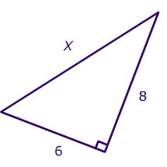 **Using the Pythagorean Theorem, find the missing side:**

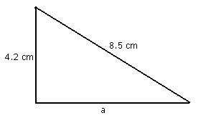39. 40.*Round to the nearest hundredth.*

C:\Program Files (x86)\Microsoft Office\MEDIA\CAGCAT10\j0285750.wmf41. In a computer catalog, a computer monitor is listed as being 19 inches. This distance is the diagonal distance across the screen. If the screen measures 10 inches in height, what is the actual width of the screen to the *nearest* inch? *(draw and label a picture first!)*

1. C:\Users\sprofio-miller\AppData\Local\Microsoft\Windows\Temporary Internet Files\Content.IE5\WNWK9OCX\MC900019094[1].wmf Oh no! At Caps Camp, there was an infestation in the cabins and all students had to camp out in tents! Looking at the map of Camp Kanata as a coordinate plane, the base site is located at the origin. The girls’ tent site is located 3 miles west and 2 miles north of the base site. The boys’ tent site is located 5 miles east and 4 miles south of the base site.
2. Find how far the boys’ tent is from the girls’ tent. ______________________________________
3. If the teacher chaperones decided to set up their tents at the midpoint between the boys’ and girls’ tent site, where would their location lie?

( __________ , ___________ )

1.  **Distance Formula: Find the distance of the following points. You can use the distance formula or the Pythagorean Theorem. Use the graph given if you wish.**
2. Find the length of the line segment whose endpoints are (-3, 4) and (5, 4).
3. Find the distance between the points (-4, -5) and (1, -2). Round to the nearest hundredth.

**DAY 11 Practice (Skill 4)**

**Finding Area and Perimeter Using the Distance Formula**

1. Draw the trapezoid with vertices (0, -7), (0, -3), (4, -3), and (7, -7).
2. Find all four side lengths. *(hint: one side you will have to use either the distance formula or Pythagorean theorem).*
3. Using your answer in part a.), find the perimeter of the shape. _________________
4. The formula for area of a trapezoid is *A* = ½ (*b*1 + *b*2)*h* where *b*1 is base 1, *b*2 is base 2 and *h* is the height. Find the area of this trapezoid.
5. Draw the triangle with vertices A(-5, -1), B(-3, 4), and C(2, 2).
6. Using the distance formula (or the Pythagorean Theorem), find the length of each side.

AB =

BC =

AC =

What do you notice about the two legs of the triangle? We call this a/an _______________ triangle.

1. Using your answers in part a.),find the perimeter. __________________
2. Find the midpoint of side AC. ( _______ , ________ ) Label this point D on the graph on the previous page.
3. Using the distance formula again, find the length of BD.
4. Use your lengths for BD and AC to find the area of the triangle.

Area = _______________