Math I Mrs. Orr Name: \_\_\_\_\_\_\_\_\_\_\_\_\_\_\_\_\_\_\_\_\_\_\_

Unit 7: Quadratic Functions

|  |  |  |  |  |
| --- | --- | --- | --- | --- |
| **Day** | **Date** | **Topic** | **CW** | **Grade/Stamp**  **(Teacher fills in)** |
| 1 | Tuesday, April 5th | Parts of a Quadratic | pg. 3 |  |
| 2 | Thursday, April 7th | Linear vs Exp vs Quad Graphs  Transformations | pg. 4 |  |
| 3 | Monday, April 11th | Vertex (Max and Mins) | pg. 5 |  |
| 4 | Wednesday, April 13th | Projectile Motion – Finding zeros | pg. 6 |  |
| 5 | Friday, April 15th | Review | pg. 7-9 |  |
| 6 | Tuesday, April 19th | **QUIZ**  Polynomial Operations Review | pg. 10 |  |
| 7 | Thursday, April 21st | Factoring | pg. 11 |  |
| 8 | Monday, April 25th | Factoring to find Quadratic Solutions | pg. 12 |  |
| 9 | Tuesday, April 26th | Review | **Turn in your HW packet today!** | |
| 10 | Thursday, April 28th | **TEST**  Need tutoring or to make up an assignment? Stay after school on **Tuesdays and Thursdays from 2:30—3:30 pm**! | **Yay! You finished the hard unit!** | |

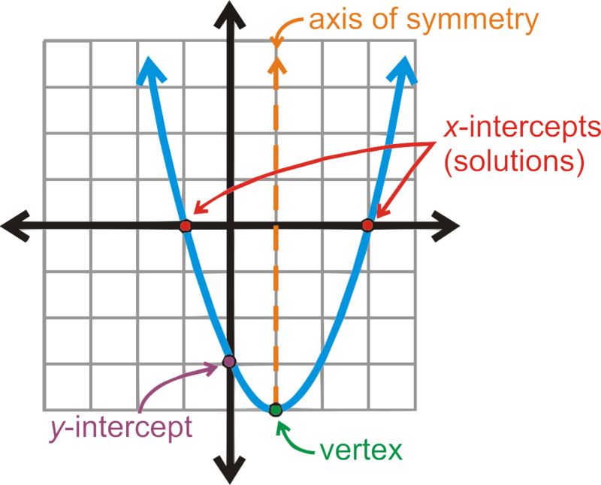



Need some online help? Go to [www.sascurriculumpathways.com](http://www.sascurriculumpathways.com) (Login: BroughtonStudent) and use QL#s 1320, 1321, 1420, and 1445.

**Unit 7: Quadratic Functions**

**Skill 19: I CAN Create, Solve, and Operate with Quadratic Functions**

**Perform arithmetic operations on polynomials.**

**A-APR.1** Understand that polynomials form a system analogous to the integers, namely, they are closed under the operations of addition, subtraction, and multiplication; add, subtract, and multiply polynomials.

***Note:***  *At this level, limit to addition and subtraction of quadratics and multiplication of linear expressions.*

## Write expressions in equivalent forms to solve problems.

**A-SSE.3** Choose and produce an equivalent form of an expression to reveal and explain properties of the quantity represented by the expression.★

1. Factor a quadratic expression to reveal the zeros of the function it defines.

***Note:*** *At this level, the limit is quadratic expressions of the form ax2 + bx + c.*

**F-IF.8** Write a function defined by an expression in different but equivalent forms to reveal and explain different properties of the function.

1. Use the process of factoring and completing the square in a quadratic function to show zeros, extreme values, and symmetry of the graph, and interpret these in terms of a context.

***Note:*** *At this level, only factoring expressions of the form ax2 + bx +c, is expected. Completing the square is not addressed yet.*

**Create equations that describe numbers or relationships.**

**A-CED.2** Create equations in two or more variables to represent relationships between quantities; graph equations on coordinate axes with labels and scales.

***Note:*** *At this level, focus on linear, exponential and quadratic. Limit to situations that involve evaluating exponential functions for integer inputs.*

**Build a function that models a relationship between two quantities.**

**F-BF.1** Write a function that describes a relationship between two quantities. ★

1. Determine an explicit expression, a recursive process, or steps for calculation from a context.
2. Combine standard function types using arithmetic operations. *For example, build a function that models the temperature of a cooling body by adding a constant function to a decaying exponential, and relate these functions to the model.*

***Note:*** *At this level, limit to addition or subtraction of constant to linear, exponential or quadratic functions or addition of linear functions to linear or quadratic functions.*

**Skill 20: I CAN Graph and Interpret Quadratic Functions**

**Interpret functions that arise in applications in terms of the context.**

**F-IF.4** For a function that models a relationship between two quantities, interpret key features of graphs and tables in terms of the quantities, and sketch graphs showing key features given a verbal description of the relationship. *Key features include: intercepts; intervals where the function is increasing, decreasing, positive, or negative; relative maximums and minimums; symmetries; end behavior; and periodicity.* ★

***Note:*** *At this level, focus on linear, exponential and quadratic functions; no end behavior or periodicity.*

**F-IF.7** Graph functions expressed symbolically and show key features of the graph, by hand in simple cases and using technology for more complicated cases. ★

1. Graph linear and quadratic functions and show intercepts, maxima, and minima.

**F-IF.9** Compare properties of two functions each represented in a different way (algebraically, graphically, numerically in tables, or by verbal descriptions). *For example, given a graph of one quadratic function and an algebraic expression for another, say which has the larger maximum.*

***Note:*** *At this level, focus on linear, exponential, and quadratic functions.*

Day 1 Practice

**Label the following on all of the graphs below. Use a yellow highlighter to indicate where the graphs increase, and a different color to show where the graphs decrease.**

1. Axis of Symmetry
2. X-Intercepts
3. Zeros/Roots
4. Y-Intercept
5. Vertex

**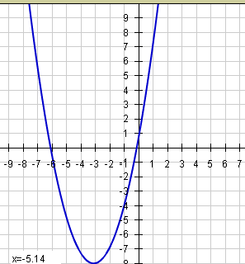A1** **A2.**

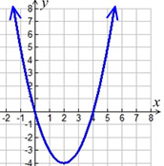

**B**  **C.** Graph the equation: C:\Documents and Settings\sschmucker\Application Data\PixelMetrics\CaptureWiz\Temp\1.png(Hint: You can make a table)

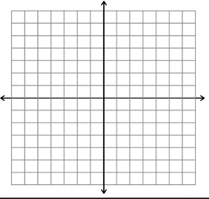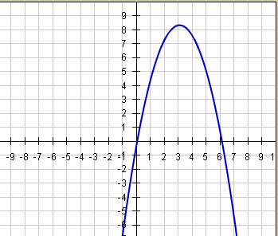

Day 2 Practice

**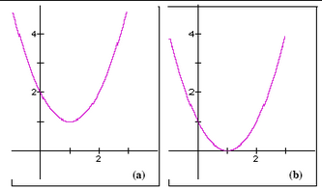1. The following are transformed from the first graph/equation to the second. Compare the two graphs and answer the questions by using your calculator and knowledge about transformations.**

**A.**  **I** to **II **

Is **(b**) shifted up, down, right, left, or none? \_\_\_\_\_\_\_\_\_\_ Is **II** shifted up, down, right, left, or none? \_\_\_\_\_\_\_\_\_\_

Is **(b)’s** y-intercept larger, smaller, or the same? \_\_\_\_\_\_\_\_ Is **II’s** y-intercept larger, smaller, or the same? \_\_\_\_\_\_\_

Is **(b)’s** graph narrower, wider, or the same? \_\_\_\_\_\_\_\_\_\_ Is **II’s** graph narrower, wider, or the same? \_\_\_\_\_\_\_\_\_\_

Did **(b)’s** graph “reflect” or “flip”? \_\_\_\_\_\_\_\_\_\_\_\_ Did **II’s** graph “reflect” or “flip”? \_\_\_\_\_\_\_\_\_\_\_\_

**2. Write a quadratic equation for the following situations:**

1. Given the quadratic equation *f*(*x*) = *x*2, write a new equation that is moved down 3 units and opens downward.

\_\_\_\_\_\_\_\_\_\_\_\_\_\_\_\_\_\_\_\_\_\_\_\_\_\_\_\_\_\_\_\_\_

1. Given the quadratic equation *y* = *x*2, write a new equation that has the same y-intercept but whose graph is narrower.

\_\_\_\_\_\_\_\_\_\_\_\_\_\_\_\_\_\_\_\_\_\_\_\_\_\_\_\_\_\_\_\_\_

1. Given the quadratic equation *f*(*x*) = 2*x*2 – 5 write a new equation with the y-intercept increased by 6, but whose graph is wider.

\_\_\_\_\_\_\_\_\_\_\_\_\_\_\_\_\_\_\_\_\_\_\_\_\_\_\_\_\_\_\_\_\_

3A. Finish each table and state whether it represents linear, exponential, or quadratic growth:

|  |  |  |  |  |  |  |  |  |  |  |  |  |  |  |  |  |  |  |  |  |  |  |  |  |  |  |  |  |  |  |  |  |  |  |  |  |  |  |
| --- | --- | --- | --- | --- | --- | --- | --- | --- | --- | --- | --- | --- | --- | --- | --- | --- | --- | --- | --- | --- | --- | --- | --- | --- | --- | --- | --- | --- | --- | --- | --- | --- | --- | --- | --- | --- | --- | --- |
| |  |  | | --- | --- | | x | y | | 1 | 5 | | 2 | 7 | | 3 | 9 | | 4 |  | | 5 |  |   \_\_\_\_\_\_\_\_\_\_\_\_\_\_\_\_\_\_\_\_\_\_\_\_\_\_ | |  |  | | --- | --- | | x | y | | 1 | 0 | | 2 | 3 | | 3 | 8 | | 4 | 15 | | 5 |  |   \_\_\_\_\_\_\_\_\_\_\_\_\_\_\_\_\_\_\_\_\_\_\_\_\_\_ | |  |  | | --- | --- | | x | y | | 1 | 3 | | 2 | 9 | | 3 | 27 | | 4 |  | | 5 |  |   \_\_\_\_\_\_\_\_\_\_\_\_\_\_\_\_\_\_\_\_\_\_\_\_\_\_ |

**Day 3 Practice**

**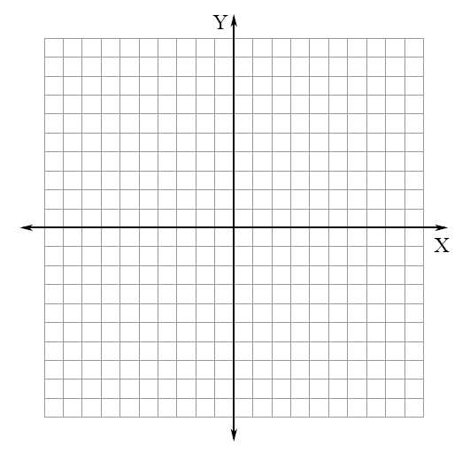A. Directions: Use the graphing calculator to identify the critical points of the parabola. Use the critical points to sketch the graph.**

$y=x^{2}+x-6$

Maximum OR Minimum

Vertex \_\_\_\_\_\_\_\_\_\_\_\_\_\_\_\_\_\_\_\_\_\_\_\_\_\_\_\_\_

Axis of Symmetry \_\_\_\_\_\_\_\_\_\_\_\_\_\_\_\_\_\_\_\_

Increasing interval \_\_\_\_\_\_\_\_\_\_\_\_\_\_\_\_\_\_\_

Decreasing interval \_\_\_\_\_\_\_\_\_\_\_\_\_\_\_\_\_\_\_

**B1. Manufacturing** An electronics company has a new line of portable radios with CD players. Their research suggests that the daily sales *s* for the new product can be modeled by , where *p* is the price of each unit.

1. Find the maximum daily sales. **b)** What price will result in that maximum?

****

**C1.** A barber’s profit, $p$, each week depends on his charge, $c$, per haircut. It is modeled by the equation

$p=-200c^{2}+2400c-4700$.

1. What is his maximum profit? **b)** What should he charge per haircut to achieve this max profit?

**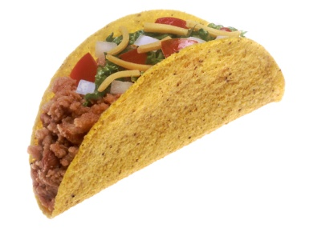B2.** Mrs. DeBaer and Ms. Kinkaid have decided to open a food truck and sell tacos on Saturdays nights to make extra money. Their daily costs are modeled by the equation $f\left(x\right)=x^{2}-40x+610$, where $C\left(x\right)$ is their daily costs and $x$ is the number of tacos.

**a)** How many tacos should they sell to minimize their cost? **b)** What is their minimum cost?

Description: AN01125_**C2. Woodland Jumping Mouse** The woodland jumping mouse can hop surprisingly long distances given its small size. A relatively long hop can be modeled by  where *x* and *y* are measured in feet.

**a)** How far can a woodland jumping mouse hop? **b)** Can this mouse jump a tree stump that is 3.5 ft high?

Day 4 Practice

**A1**. What are the solutions of the following quadratic functions?

1.  ( \_\_\_\_\_, \_\_\_\_\_) b. *y* = *x*2 + 5*x* + 6 ( \_\_\_\_\_, \_\_\_\_\_)

( \_\_\_\_\_, \_\_\_\_\_) ( \_\_\_\_\_, \_\_\_\_\_)



**A2.**

*x*-intercept(s) \_\_\_\_\_\_\_\_\_\_

*y*-intercept \_\_\_\_\_\_\_\_\_\_\_

Zeros \_\_\_\_\_\_\_\_\_\_\_\_\_\_\_\_\_\_\_\_

**A3. a.)** What is another way of saying “solution” for a quadratic function? \_\_\_\_\_\_\_\_\_\_\_\_\_\_\_\_\_\_\_\_\_\_\_\_\_\_\_\_\_\_\_\_\_\_\_

**b.)** What is the solution of the quadratic function in #A2? \_\_\_\_\_\_\_\_\_\_\_\_\_\_\_\_\_\_\_\_\_\_\_\_\_\_\_\_\_\_\_\_\_

**B. Field Hockey** Suppose a player makes a scoop that releases the ball with an upward velocity of 34 ft/s. The function  models the height *h* in feet of the ball at time *t* in seconds. Will the ball ever reach a height of 20 ft? Explain. When will the ball hit the ground?

**C. Throwing A Ball** A player throws a ball up and toward a wall that is 17 feet high. The height *h* in feet of the ball *t* seconds after it leaves the player’s hand is modeled by . If the ball makes it to where the wall is, will it go over the wall or hit the wall? Explain. When will the ball hit the ground?

**REVIEW SHEET for Quiz**

**1.** Examine each graph. Each parabola graph is associated with a quadratic equation. Determine the number of real solutions that the associated quadratic equation would have:





A. B. C.

**2.** Label the following items on the graph below:

* x-intercepts, y-intercept, axis of symmetry, vertex
* Does this parabola have a *maximum* or a *minimum*?
* Use your pencil to shade the section of the parabola that is **increasing**. Use a different colored pen/pencil to shade the section of the parabola that is **decreasing**.
* State the equation for the axis of symmetry; state the domain over which the function is increasing; state the domain over which the function is decreasing

[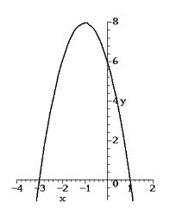](http://www.google.com/imgres?sa=X&rls=com.microsoft:en-us:IE-SearchBox&biw=1024&bih=584&tbm=isch&tbnid=QD-VFMqqyBnWmM:&imgrefurl=http://www.math.utah.edu/online/1010/parabolas/&docid=feEoVyZZbRsf9M&imgurl=http://www.math.utah.edu/online/1010/parabolas/prob/example.gif&w=306&h=398&ei=AfoMU92DGKSU0QHOyYDQBA&zoom=1&iact=rc&dur=1328&page=1&start=0&ndsp=10&ved=0CHYQrQMwCQ)

**3.** Use your graphing calculator to complete the table:

|  |  |  |
| --- | --- | --- |
| ***Function*** | $$y=x^{2}-2x-8$$ | $$y=-2x^{2}-3x+2$$ |
| ***Vertex*** | **( , )** | **( , )** |
| ***Maximum or Minimum?*** |  |  |
| ***Axis of Symmetry*** | **x = \_\_\_\_\_\_\_\_\_** | **x = \_\_\_\_\_\_\_\_\_** |
| ***x-intercept(s)*** |  |  |
| ***y-intercept*** |  |  |
| ***Domain of function*** |  |  |
| ***Range of function*** |  |  |

**4.** List all terms that mean the same as: “solution of a quadratic”: \_\_\_\_\_\_\_\_\_\_, \_\_\_\_\_\_\_\_\_\_\_, \_\_\_\_\_\_\_\_\_\_\_\_

**5.** Graph, using your graphing calculator: f(x) = − x2 + 6x – 8

What does the constant, −8, tell us about the graph? \_\_\_\_\_\_\_\_\_\_\_\_\_\_\_\_\_\_\_\_

What does the lead coefficient, −1, tell us about the graph? \_\_\_\_\_\_\_\_\_\_\_\_\_\_\_\_\_\_\_\_

**6.** Write the quadratic equation for the following situations:

a. Given: f(x) = x2 the parabola is shifted down 1 unit

b. Given: f(x) = −x2 the parabola is reflected over the x-axis.

c. Given: f(x) = x2 + 4 the parabola is shifted down 5 units and is reflected over the x-axis

d. Given: f(x) = −x2 – 4 the parabola is shifted up 3 units

e. Given: f(x) = x2 the parabola has the same y-intercept, but the graph is wider

Application Problems

**7.** You are building a swimming pool that has a length 8 ft longer than the width. What is the maximum area of your pool?

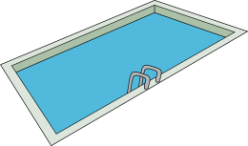

C:\Documents and Settings\sprofio\Local Settings\Temporary Internet Files\Content.IE5\IHDMY4V9\MC900286500[1].wmf

**8.** Miley and Kiki are hiking in the mountains and stop for lunch on a ledge 1000 feet above the valley below. Kiki decides to climb to another ledge 20 feet above Miley. Miley throws an apple up to Kiki. The function that represents the height, in feet, of the apple *t* seconds after it was thrown is: $h\left(t\right)= -16t^{2} + 30t+1000$

a) Was it possible for Kiki to catch the apple? Explain: \_\_\_\_\_\_\_\_\_\_\_\_\_\_\_\_\_\_\_\_\_\_\_\_\_\_\_\_\_\_\_\_\_\_\_\_\_

b) How long did it take for the apple to hit the ground? \_\_\_\_\_\_\_\_\_\_\_\_\_\_

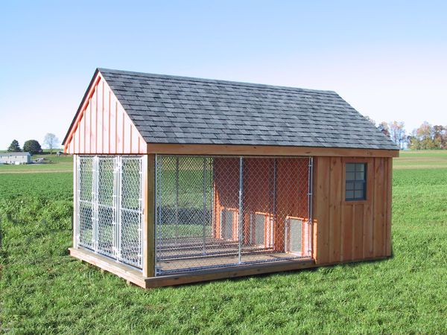

**9.** You want to build a dog pen for your new puppy, Valvano. You have 36 feet of fencing with which to enclose your dog pen. You decide to place fencing on three sides of the pen and use your shed to complete the enclosed area. Draw a picture to illustrate this situation. Write a quadratic equation to model this situation. Graph the equation with your graphing calculator and answer the following:

a) What is the maximum area of Valvano’s pen? \_\_\_\_\_\_\_\_\_\_\_\_\_

b) What are the dimensions of Valvano’s pen? \_\_\_\_\_\_\_\_\_\_\_\_

C:\Documents and Settings\sprofio\Local Settings\Temporary Internet Files\Content.IE5\IHDMY4V9\MC900348403[1].wmf

**10.** At a festival, pumpkins are launched with large cannons. On one launch, the height (in feet) of a pumpkin above the ground after *t* seconds is modeled by: $h\left(t\right)=-16t^{2}+200t+15$

a) Sketch the path of the pumpkin. Include the following on your graph:

Labeled axes.

Circle the point when the pumpkin was launched.

Draw a square around the point for the max height.

Draw an arrow to indicate when it hit the ground.

Use your graphing calculator to graph and answer the following:

b) From what height was the pumpkin launched? \_\_\_\_\_\_\_\_\_\_\_

c) When did the pumpkin reach its maximum height? \_\_\_\_\_\_\_\_\_\_

d) What was the maximum height that the pumpkin reached? \_\_\_\_\_\_\_\_\_\_\_

e) How long was the pumpkin in the air? \_\_\_\_\_\_\_\_\_\_\_\_

f) What was the height of the pumpkin after: 3 seconds? \_\_\_\_\_\_\_ 4 seconds? \_\_\_\_\_\_\_ 8.5 seconds? \_\_\_\_\_\_\_

Day 6 Practice

**Perform each operation. Name your solution by degree and number of terms.**

**A1) $(x + 8)(x + 4)$** **B1) $(x + 9)(x – 3)$**

**C1) $(3x + 4) (3x – 4)$** **A2) $(x- 10)(x+ 8)$**

**B2) $(x – 10)(x – 8)$** **C2) $(2x – 5)$**

**A3) $(2x + 3)(3x – 4)$** **B3) $(b+1)(-4b^{2} + 6b – 5)$**

**C3) $\left(2x^{2}-8x+9\right)\left(3x^{2}+4x-11\right)$** **A4) $\left(4x^{2}-9x\right)-\left(x^{2}-5x-10\right)$**

**B4) $\left(2x-7x^{2}+1\right)-\left(2x^{2}+6x+1\right)$** **C4) $\left(5x+9\right)+\left(6x-7\right)+(1-8x)$**

**APPLICATIONS**

**A)** The perimeter of a square is $16x+24$. Find the length of one side.

**B)** The perimeter of an isosceles triangle is $17x+13$. If the length of the base is $5x+7$, find the lengths of the other two sides.

**C)** The dimensions of a rectangular pool are $\left(2x+3\right)$ and $(3x-1)$. Find the area of the pool.

**ERROR ANALYSIS**

**A)** Describe and correct the error in finding the difference of the polynomials.

*Step 1:* (4*x*2 – *x* + 3) – (3*x*2 – 8*x* – 9)

*Step 2:* 4*x*2 – *x* + 3 – 3*x*2 – 8*x* – 9

*Step 3:* 4*x*2 – 3*x*2 – *x* – 8*x* + 3 – 9

*Step 4:* *x*2 – 9*x* – 6

Day 7 Practice

**Factor by finding a GCF.**

**A1. $20x^{4}+12x^{3}$** **A2. $18n^{2}+6n$** **A3. $6p^{3}-18p^{2}-9p$**

**Factor each trinomial.**

**A4. $x^{2}-5x-14$** **A5. $x^{2}+x-72$** **A6. $x^{2}+9x+8$**

**B1. $x^{2}-10x+16$** **B2. $x^{2}-25$**

**B3. $x^{2}-2x+1$** **B4. $4x^{2}-9$**

**C1. $144-x^{2}$**  **C2. $x^{2}+4x-21$**

**C3. $9x^{2}y^{3}+27x^{5}y$**   **C4. $2x^{2}-16x+14$**

Day 8 Practice

**Solve each equation by factoring.**

**A1.) $2x\left(x-7\right)=0$** **A2.) $x\left(x+4\right)=0$** **A3.) $-3y\left(2y-1\right)=0$**

**A4.) $\left(k-1\right)\left(k-5\right)=0$** **A5.) $\left(a+1\right)\left(a+2\right)=0$** **A6.) $\left(4m+5\right)\left(m+1\right)=0$**

**B1.) $(2m+3)\left(4m+3\right)=0$** **B2.) $x^{2}-11x+24=0$** **B3.) ${4n}^{2}+28n+40=0$**

**B4.) $a^{2}-10n+22=-2$** **B5.) $h^{2}-18h+81=0$** **B6.) $x^{2}+8x=-15$**

**C1.) $b^{2}+5b-35=3b$** **C2.) $3w^{2}-6w-24=0$** **C3.) $x^{2}-25=0$**

**C4.) $7x^{2}+2x=0$** **C5.) $5c^{2}-6c+3=3$**  **C6.)** *Challenge! ${4n}^{2}+6n+9=0$*