Math I Mrs. Orr Name: _______________________

Unit 5: Systems of Linear Functions

|  |  |  |  |
| --- | --- | --- | --- |
| **Day** | **Date** | **Topic** | **Grade** |
| 1 | Monday, January 4th | Review of Lines |  |
| 2 | Wednesday, January 6th | Comparison of two lines: Interpretation of slope, *x* and *y* intercepts  **HW:** pg. 3 (#1) |  |
| 3 | Friday, January 8th | Comparison of two lines:  Finding where two lines intersect  **HW:** pg. 3 – 4 (#2 and 3) |  |
| 4 | Tuesday, January 13th | Comparison of two lines: parallel and perpendicular  **HW:** pg. 4 (#4 – 6) |  |
| 5 | Thursday, January 15th | *END of 2nd quarter*  **QUIZ**  **HW:** None ☺ |  |
| **End of 1st Semester** | | | |
| 6 | Wednesday, January 20th | Review Solving by Graphing  Intro to Substitution  **HW:** pg. 5 (#7 – 9) |  |
| 7 | Friday, January 22nd | Substitution continued  **HW:** pg. 6 (#10 – 13) |  |
| 8 | Tuesday, January 26th | Elimination  **HW:** pg. 7 (#14 – 18) |  |
| 9 | Thursday, January 28th | Elimination continued/Applications  **HW:** pg. 8 (#19 – 25) |  |
| 10 | Monday, February 1st | Review  **HW:** Review Sheet | *Finish/Show work on review sheet and attach to HW packet for 2 extra points!* |
| 11 | Wednesday, February 3rd | **TEST** | *Turn in this packet today for HW grade!* |



REMINDER….check class website for helpful links and copies of notes! [www.calculatORR.weebly.com](http://www.calculatORR.weebly.com)

(Click on Common Core Math 1 🡪Unit 4 pt. 2)

Come to see Mrs. Orr for **tutoring** on

Tues. and Thurs.

2:30 – 3:30 pm

**Unit 5 Systems Skills**

**Skill 13: I can CREATE linear equations and COMPARE their slopes.**

**G-GPE.5** Prove the slope criteria for parallel and perpendicular lines and use them to solve geometric problems (e.g., find the equation of a line parallel or perpendicular to a given line that passes through a given point).

**A-CED.2** Create equations in two or more variables to represent relationships between quantities; graph equations on coordinate axes with labels and scales.

***Note:*** *At this level, focus on linear, ~~exponential and quadratic~~.  ~~Limit to situations that involve evaluating exponential functions for integer inputs.~~*

**A-CED.3** Represent constraints by equations or inequalities, and by systems of equations and/or inequalities, and interpret solutions as viable or non- viable options in a modeling context. *For example, represent inequalities describing nutritional and cost constraints on combinations of different foods.*

***Note:*** *At this level, limit to linear equations and inequalities.*

**Skill 14: I can SOLVE a system of equations.**

**Analyze and solve linear equations and pairs of simultaneous linear equations.**

**8.EE.8** Analyze and solve pairs of simultaneous linear equations.

1. Understand that solutions to a system of two linear equations in two variables correspond to points of intersection of their graphs, because points of intersection satisfy both equations simultaneously.
2. Solve systems of two linear equations in two variables algebraically, and estimate solutions by graphing the equations. Solve simple cases by inspection. *For example, 3x + 2y = 5 and 3x +* *2y = 6 have no solution because 3x + 2y cannot simultaneously be 5* *and 6.*
3. Solve real-world and mathematical problems leading to two linear equations in two variables. *For example, given coordinates for two* *pairs of points, determine whether the line through the first pair of* *points intersects the line through the second pair.*

**Solve systems of equations.**

**A-REI.5** Prove that, given a system of two equations in two variables, replacing one equation by the sum of that equation and a multiple of the other produces a system with the same solutions.

**A-REI.6** Solve systems of linear equations exactly and approximately (e.g., with graphs), focusing on pairs of linear equations in two variables.

**Skill 15 (assessed by graded assignment– not on the test):**

**I can REPRESENT and SOLVE inequalities graphically.**

**A-REI.12** Graph the solutions to a linear inequality in two variables as a half- plane (excluding the boundary in the case of a strict inequality), and graph the solution set to a system of linear inequalities in two variables as the intersection of the corresponding half-planes.

Day 2 Homework: Comparison of Two Lines

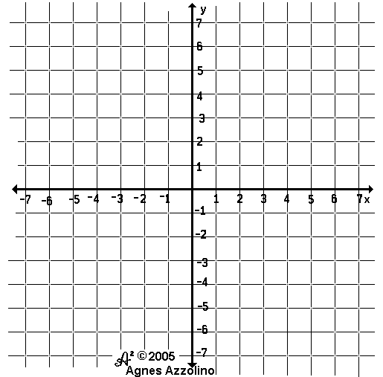**1.** Graph the lines on the same graph on the right- using either intercepts or slope-intercept form. Show work!!! Then answer the questions about the lines.

Line 1: 

Line 2: 

1. Name the intercepts of both lines:

Line 1: *x*-intercept: __________ *y*-intercept: ____________

Line 2: *x*-intercept: __________ *y*-intercept: ____________

1. Which line has the steepest slope? How do you know? __________________________________
2. Circle on the graph where the two lines intersect. Write the point of intersection: (____, ____)
3. Write the equation of Line 1 if you moved it down 3 units: ___________________
4. Write a new equation of a line if it had double Line 1’s slope and half of Line 2’s y-intercept: _______________

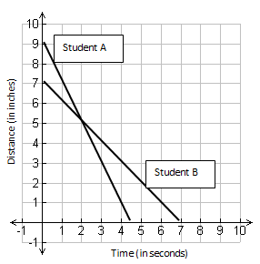Day 3 Homework: Comparison of Two Lines - finding their intersection

**2.** Two students conduct an experiment where they walk towards a motion detector and measured their distance.

a. How far away from the motion detector did Student A begin? _______________ How far away from the motion detector did Student B begin? ___________________ What do we call this characteristic of a line? _____________________________

b. Find the rate of change for student A: _________ per second Find the rate of change for student B: _________ per second .

Who is walking faster towards the motion detector? ____________

c. At what time is Student A and Student B at the same distance from the motion detector? _______________

d. At what time does Student A reach the motion detector? _____________ At what time does Student B reach the

motion detector? _____________ What do we call this characteristic of a line? ______________________

e. Write the equation of the line for each student. Student A: _________________ Student B: _________________

**DAY 3 HOMEWORK CONTINUED ON NEXT PAGE!!!**

**3.** Graph the following lines and find where they intersect – write the intersection as an ordered pair.

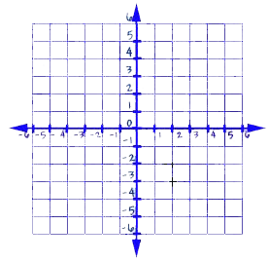a.) $\left\{\begin{aligned}y=-2x+4 \\ y=4x-2\end{aligned}\right.$ Intersection: ( ____, ____ ) c.) $\left\{\begin{aligned}2x+3y=6 \\ x-y=-2\end{aligned}\right.$ Intersection: (____, ____)



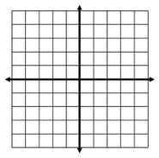Day 4 Homework: Comparison of Two Lines - parallel and perpendicular lines

**4.** Given the points: **M(-1, 3) A(5, 0) T(3, -4) H( -3, 1)**, answer the following questions.

a.) Graph the following points on the given graph. Connect to create a quadrilateral.

b.) A rectangle is a quadrilateral with each corner is a right angle. Find the slopes of each line to prove if each corner is a right angle, thus proving if it is a right angle.

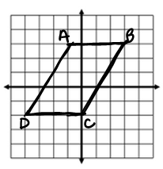**5.** A parallelogram is a quadrilateral with two sets of opposite parallel sides. Find the slopes of each side of the quadrilateral on the right to justify that this is a parallelogram.



Slope of AB = Slope of BC =

Slope of DC = Slope of AD =

Explanation:

**6.**  Given the line .

a.) Write an equation that is perpendicular to the above line: _________________

b.) Write an equation that is parallel to the above line: _________________

Day 6 Homework: Solving System by Graphing and Substitution

1. Find the solution of the following systems by graphing:
2. $\left\{\begin{aligned}y=6x+4 \\ y=4x-2\end{aligned}\right.$ b. $\left\{\begin{aligned}2x+y=-1 \\ x=2y+12\end{aligned}\right.$



1. Given the system of linear equations: 2*x* + 11*y* = 70 and 5*x* + 3*y* = 20

Is (3, 6) a solution to this system of equations? ______ Show work below:

1. 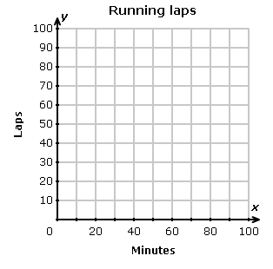Samson and Perry got in trouble at football practice and have to run laps as a consequence. Samson, who runs at a rate of 1 lap per minute, had completed 10 laps already when he was joined on the track by Perry. Perry's pace is 2 laps per minute. At some point, the two will have run the same distance. How many laps will each boy have run?
2. Graph a line for each student on the coordinate plane.
3. Write an equation for Samson using y for laps and x for minutes: _____________________
4. Write an equation for Perry using y for laps and x for minutes: _____________________
5. Find the intersection of the two lines: _________

What information does this point give you?

Day 7 Homework: Solving System by Substitution

**Use substitution to solve each system of equations. SHOW WORK!!!!**

**10. $\begin{matrix}y=6x \\ 2x+3y=-20\end{matrix}$** **11. $\begin{matrix}y=2x+6 \\ 2x-y=2\end{matrix}$** **12. $\begin{matrix}2x+4y=10 \\ x-4y=-2.5\end{matrix}$**

**13.** Kenisha sells athletic shoes part-time at a department store. She can choose from two payment options. Option 1: Get paid $500 per month plus 4% commission on her total sales or Option 2: Get paid $400 per month plus a 5% commission on total sales.

a. Write a system of equations to represent each option for payment.

b. How much does Kenisha need to sell in order to earn the same amount from each pay option?

c. Which is the better offer and why?

Day 8 Homework: Solving System by Elimination

**Solve each system using the elimination method. SHOW WORK!!!!**

**14. $\begin{matrix}4x-6y=-48 \\ x+6y=18\end{matrix}$** **15. $\begin{matrix}2x+6y=8 \\ 2x+6y=5\end{matrix}$**

**16**. $\begin{matrix}5x-2y=-10 \\ 3x+6y=66\end{matrix}$**17. $\begin{matrix}2x+3y=14 \\ 3x-4y=4\end{matrix}$**

**18.** The admission fee at a small fair is$1.50 for children and $4.00 for adults. On a certain day, 2200 people enter the fair and $5050 is collected. How many children and how many adults attended?

a.) Define your variables. *x* represents ________________________ *y* represents _________________________

b.) Set up two equations: Admission equation: _______________________________________

Total # of people equation: ________________________________________

c.) Solve the system of equations using which ever technique you choose.

d.) Write the answer in context of the situation.

Day 9 Homework: Solving System by Substitution and Elimination

**CHOOSE 4 PROBLEMS TO COMPLETE BELOW.**

**Define your variables for each problem. Set up the equations and solve. Be able to explain the meaning of the solution. Show work!!!!!!!**

1. Admission to a certain amusement park is either $6 plus 25 cents per ride or $4 plus 50 cents per ride. At what number of rides is the cost the same?
2. A total of 239 tickets were sold last week. Student tickets were $1 each and non-student tickets were $2 each. If the total income from the tickets was $322, how many of each ticket were sold?
3. In the high school choir there are 6 more boys than girls. The total number of choir members is 44. How many girls are in the choir?
4. Jerry has a collection of dimes and quarters worth $13.60. He has 4 more quarters than dimes. How many dimes does he have?
5. The sum of two numbers is 56 and their difference is 20. Find each of the numbers.
6. The sum of three times Keri’s age and 5 times Myra’s age is 104. Keri is 2 years less than twice as old as Myra. Find each of their ages.
7. The cost of 4 T-shirts and 5 pair of jeans is $138. The cost of 2 T-shirts and 6 pair of jeans is $132. Find the cost of each.