Math I Mrs. Orr Name: _______________________

Unit 4: Linear Functions

|  |  |  |  |
| --- | --- | --- | --- |
| **Day** | **Date** | **Topic** | **Grade**  (Teacher fills in – stamp means that work is completed and worth 5 pts) |
| **A** |
| 1 | Monday, Nov. 16th | Slope/Rate of Change  HW: pg. 3 (#1 – 4) |  |
| 2 | Wed, Nov. 18th | Slope-Intercept Form  HW: pg. 4 (#5 – 7) |  |
| 3 | Friday, Nov. 20th | More Slope-Intercept Form  HW: pg 5 (#8 – 10) |  |
| 4 | Tuesday, Nov. 24th | **PROJECT**  Review of Lines | *Work on Project 🡪*  *Due Friday 12/11 A-day* |
| 5 | Tuesday, Dec. 1st | Applications of Lines in Slope-Intercept Form  HW: pg 6 (#11 – 15) |  |
| 6 | Thursday, Dec. 3rd | **QUIZ** on Day 1 -3 Material  Converting to Slope-Intercept Form  HW: pg. 7 (#16 – 20) |  |
| 7 | Monday, Dec. 7th | Review Day  HW: Review Sheet | *Complete review sheet to help study for the test!* |
| 8 | Wed.,Dec. 9th | **TEST TODAY**  (This packet will be collected today!) | *Project due next class!* |

REMINDER….check class website for helpful links:

[www.calculatORR.weebly.com](http://www.calculatORR.weebly.com)

(Click on Math 1 🡪 Unit 4)

Come see Mrs. Orr for **tutoring** on

Tuesdays/Thursdays

2:30 – 3:30 pm

SAS Curriculum Pathways Help

QL#s 5001, 5002, 5003, 5004

[www.sascurriculumpathways.com](http://www.sascurriculumpathways.com)

Login: BroughtonStudent

No password necessary

**Unit 4: Linear Functions Skills & Standards**

**Skill 11: I can BUILD and MODEL Linear Functions**

**Build a function that models a relationship between two quantities.**

**F-BF.1** Write a function that describes a relationship between two quantities. ★

1. Determine an explicit expression, a recursive process, or steps for calculation from a context.
2. Combine standard function types using arithmetic operations. *For example, build a function that models the temperature of a cooling body by adding a constant function to a decaying exponential, and relate these functions to the model.*

**Build new functions from existing functions.**

**F-BF.3** Identify the effect on the graph of replacing *f(x)* by *f(x) + k, k f(x), f(kx)*, and *f(x + k*) for specific values of k (both positive and negative); find the value of *k* given the graphs. Experiment with cases and illustrate an explanation of the effects on the graph using technology. Include recognizing even and odd functions from their graphs and algebraic expressions for them.

**Construct and compare linear ~~and exponential models~~ and solve problems.**

**F-LE.1** Distinguish between situations that can be modeled with linear functions ~~and with exponential functions~~

1. Prove that linear functions grow by equal differences over equal intervals, ~~and that exponential functions grow by equal factors over equal intervals.~~
2. Recognize situations in which one quantity changes at a constant rate per unit interval relative to another.

**F-LE.2** Construct linear ~~and exponential functions~~, including arithmetic ~~and geometric sequences~~, given a graph, a description of a relationship, or two input-output pairs (include reading these from a table).

**Skill 12: I can INTERPRET Linear Functions**

**Interpret functions that arise in applications in terms of the context.**

**F-IF.6** Calculate and interpret the average rate of change of a function (presented symbolically or as a table) over a specified interval. Estimate the rate of change from a graph.★

**F-IF.7** Graph functions expressed symbolically and show key features of the graph, by hand in simple cases and using technology for more complicated cases. ★

1. Graph linear and ~~quadratic~~ functions and show intercepts, ~~maxima, and minima~~.

**F-IF.9** Compare properties of two functions each represented in a different way (algebraically, graphically, numerically in tables, or by verbal descriptions). *For example, given a graph of one quadratic function and an algebraic expression for another, say which has the larger maximum.*

**Interpret expressions for functions in terms of the situation they model.**

**F-LE.5** Interpret the parameters in a linear ~~or exponential f~~unction in terms of a context.

**Unit 4 PRACTICE PACKET**

**Unit 4 Day 1 Practice (Skill 12)**

**1. For each pair of points, plot the ordered pairs and draw a straight line through them. Then calculate the slope of the line either using the formula or rise/run (show the work!).**

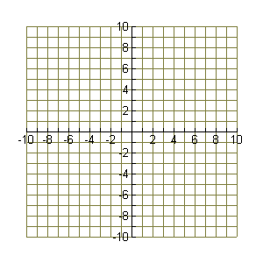a. (-1, 1) and (4, 3) m = ___ b. (-1, 5) and (2, 2) m = ___

c. (-5, 2) and (6, 2) m = ___ d. (4, 2) and (4, -6) m = ___

**2. Which problems from above have a …**

Positive slope? ______ Negative slope? ________Zero slope? _______ Undefined slope? ______

**3. State the slope given the table.**

a. m = _____ b. m = ______

|  |  |
| --- | --- |
| x | y |
| 0 | 3 |
| 1 | 7 |
| 2 | 11 |

|  |  |
| --- | --- |
| x | y |
| -1 | -2 |
| 1 | 1 |
| 3 | 4 |

**4. Find the rate of change for each situation.**

a. A hot air balloon rises from 50 feet to 400 feet in 5 minutes.

b. John did not to do his homework. Over a three week period, his grade dropped from a 95 to a 60.

**Unit 4 Day 2 Practice (Skill 11)**

**5. Write the equation of the line (in slope-intercept form) from the graph.**

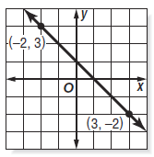

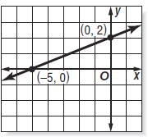a. b. c. Plot and connect the points

$\left(3, 4\right) and (-3, 0)$

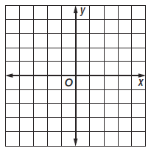

__________________ __________________ __________________

**6. Given the tables, write the Start and NOW-NEXT rule, then write the equation of the line in slope-intercept form:**

|  |  |
| --- | --- |
| ***x*** | ***y*** |
| 0 | 3 |
| 1 | 1 |
| 2 | -1 |
| 3 | -3 |
| 4 | -5 |

|  |  |
| --- | --- |
| ***x*** | ***y*** |
| 0 | 1 |
| 1 | 2.5 |
| 2 | 4 |
| 3 | 5.5 |
| 4 | 7 |

**a. b.**

START = _______ START = _______

NEXT = _________________________ NEXT = _________________________

*y* = _________________________ *y* = _________________________

**7. Write the equation of the line in slope-intercept form. Draw a graph if needed.**

a. $slope= \frac{4}{3}; passes through (0, -8)$ b. $m=-3; b=10$ c. $passes through (5, -1)and\left(0, -2\right)$

show work:

__________________ __________________ __________________

**Unit 4 Day 3 Practice (Skill 11 and 12)**

**8. Write the equation of the line in slope-intercept form. Draw a graph if needed.**

a. $slope= -2; passes through (3, 1)$ b. $m=3; b=0$ c. $passes through \left(1, 4\right)and(3, -2)$

show work:

__________________ __________________ __________________

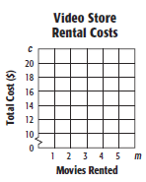

**9.** A video game store charges $10 plus $2 per movie rental.

1. Write and graph an equation in slope-intercept form.

Use m = months and c(m) = total cost

c(m) = _______________________

1. Find the cost of renting 6 movies.

Cost = _______

**10. Graph each line.**

a. $y=-\frac{2}{3}x+5$ b. $y=x-3$ c.

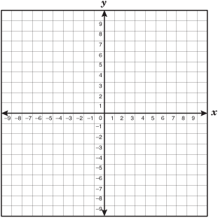

**Unit 4 Day 4 Practice (Skill 11 and 12)**

**11.** Carla had already written 10 pages of a novel. She plans to write 15 pages per month until she is finished.

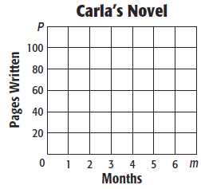

a. Write an equation to model the total number of

pages *P* written after *m* months.

__________________________________

b. Graph the equation.

c. Find the total number of pages written after

5 months. _________

d. How long will it take her to write 200 pages? _______



**Given the equation $=2x-3$,**

**12.** Graph on the grid to the right.

Slope = ________ Y-Intercept = ________

**13.** Shift the graph up four units.

a. What is the new slope? _________

b. What is the new y-intercept? ________

c. What is the special name for two lines that do not intersect? _________

**Graph $=-\frac{1}{2}x+7$.**

**14.** Which of the following points is on the line?

$(4, 5)$ $(10, 2)$ $(0,-7)$

**15.** Describe another way to determine if the points are on

the line without graphing.

**Unit 4 Day 5 Practice (Skill 12)**

**Transform each equation into slope-intercept form by solving for *y*. Then graph. Show work for all problems.**

**16. $2x+3y=0$** **17. $3y+6=2x$**  **18.**



**19. $x-4y=-8$** **20. $y+5=-2(x-1)$**

