Unit 4: Linear Functions Review Sheet Name: ____________________________________
Answer Key at the bottom of each page.

SKILL 11: I can write/build linear functions.
Level 1:  1.) The temperature is 35° and rises 4° per hour.  - Write a recursive equation representing this situation:  START = ___________  NEXT = ____________________  - If h = hours and T = temperature, write an explicit equation representing this situation.  ____________________________ | Level 3:  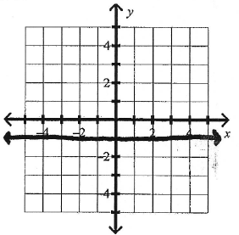  4.) Write the equation and list the type of slope of the graphs below:  - Equation: ________________  Slope: __________________  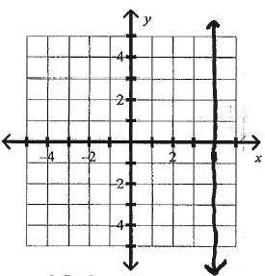  - Equation: _______________  Slope: _________ _________  5.) A school’s population is increasing at a linear rate. In the year 5, the school’s population was 2,051. In the year 13, the school’s population was 2,195.  - Find the slope. Show work.  - Find the y-intercept. Show work.  - Write an equation in slope-intercept form representing the situation:
Level 2:
x | y
-1 | -5.75
0 | -5
1 | -4.25
2 | -3.5
2.) Use the table to answer the questions:

a.) What is the slope? ______

b.) What is the y-intercept? _______

c.) Write an equation in slope-intercept form representing this situation: ______________________

3.) Find the slope and y-intercept of the graph below. Write an equation in slope-intercept form.
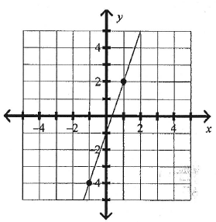

Equation: ____________________

SKILL 12: I can interpret linear functions.
Level 1:  Time (hours) Distance (miles)  1 64  2 96  3 128  4 160  6.) Given the table:  - Find the rate of change:  - Interpret in words what your answer in part a.) represents in this situation.  7.) Given the linear equation, fill in the table and graph the line:  f(x) = ½ x – 3  x f(x)  -4  -2  0  2  4 | Level 3:  11.) Two elevators are running in a high-rise hotel. Let y represent the height (in feet) above ground level and x represent time (in seconds)  Elevator 1: y = –1.4x + 230  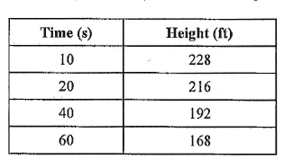  Elevator 2:  a.) Which elevator has the highest starting value? ______ by how much? ____________  b.) Which elevator has the steepest slope? ________  12.) Given the graph below representing an Athletic Club Account, answer the following equations:  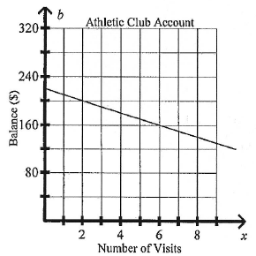  - How much did the account start with? _______  - About how much is the account decreasing per visit?  - Write an equation representing this line:  _________________________________  - How many visits will result in a balance of $140?  ____________________
Level 2:
8.) If you shift f(x) = ½ x – 3 up 3 units, what is the new equation?
____________________________

9.) If you double the slope of
f(x) = ½ x – 3, what is the new equation? _____________________

10.) Find the slope and y-intercept of the equation and graph on the line below.
–3x – 2y = –10

Work:

Slope: _____ y-int: _____ Graph this line on the graph above.

