Math I Mrs. Orr Name: _______________________

Unit 3: Functions

|  |  |  |  |
| --- | --- | --- | --- |
| **Day** | **Date** | **Topic** | **Grade**  **(1 stamp = work is complete = worth 5 points)** |
| **A** |
| 1 | Friday, October 23rd | Recursive Patterns (NOW NEXT)  HW: pg. 3 (#1 – 3) |  |
| 2 | Wednesday, October 28th | Explicit Patterns (INPUT OUTPUT)  HW: pg. 4 (#4 – 6) |  |
| 3 | Friday, October 30th | Define function/function notation Evaluating Functions  HW: pg 5 (#7 – 10) |  |
| 4 | Tuesday, November 3rd | **QUIZ** on Day 1 -3 Material  Domain and Range of Functions  HW: pg 6 (#11 – 13) |  |
| 5 | Thursday, November 5th | Interpreting Graphs  Rate of Change  HW: pg. 7 (#14 – 19) |  |
| 6 | Monday, November 9th | Extension: Translations  Review | Complete review sheet – Study for test! |
| http://brownsharpie.courtneygibbons.org/wp-content/comics/2007-02-02-stepfunction.jpg7 | Thursday, November 12th  REMINDER….check class website for helpful links and copies of notes! [www.calculatORR.weebly.com](http://www.calculatORR.weebly.com)  (Click on Math 1 🡪Unit 3) | **TEST TODAY**  (This packet will be collected today!) |  |

Come to see Mrs. Orr for **tutoring** on

Tuesdays and

Thursdays

2:30 – 3:30 pm

**GO TO BROUGHTON MATH 1 PAGE for helpful videos and practice:**

http://bhsccmath.weebly.com/math-i.html

**Unit 3: Functions**

**SKILL 8: I CAN understand functions.**

**Understand the concept of a function and use function notation.**

**F-IF.1** Understand that a function from one set (called the domain) to another set (called the range) assigns to each element of the domain exactly one element of the range. If *f* is a function and *x* is an element of its domain, then *f(x)* denotes the output of *f* corresponding to the input *x*. The graph of *f* is the graph of the equation *y = f(x*).

**F-IF.2** Use function notation, evaluate functions for inputs in their domains, and interpret statements that use function notation in terms of a context.

**F-IF.3** Recognize that sequences are functions, sometimes defined recursively, whose domain is a subset of the integers. *For example, the Fibonacci sequence is defined recursively by f(0) = f(1) = 1, f(n+1) = f(n) + f(n-1) for n ≥ 1.*

**SKILL 9: I CAN interpret functions.**

**Interpret functions that arise in applications in terms of the context.**

**F-IF.4** For a function that models a relationship between two quantities, interpret key features of graphs and tables in terms of the quantities, and sketch graphs showing key features given a verbal description of the relationship. *Key features include: intercepts; intervals where the function is increasing, decreasing, positive, or negative; relative maximums and minimums; symmetries; end behavior; and periodicity.* ★

**F-IF.5** Relate the domain of a function to its graph and, where applicable, to the quantitative relationship it describes. *For example, if the function h(n) gives the number of person-hours it takes to assemble n engines in a factory, then the positive integers would be an appropriate domain for the function.* ★

**F-IF.6** Calculate and interpret the average rate of change of a function (presented symbolically or as a table) over a specified interval. Estimate the rate of change from a graph.★

**SKILL 10: I CAN build/write functions.**

**Build a function that models a relationship between two quantities.**

**F-BF.1** Write a function that describes a relationship between two quantities. ★

1. Determine an explicit expression, a recursive process, or steps for calculation from a context.
2. Combine standard function types using arithmetic operations. *For example, build a function that models the temperature of a cooling body by adding a constant function to a decaying exponential, and relate these functions to the model.*

**F-BF.3** Identify the effect on the graph of replacing *f(x)* by *f(x) + k, k f(x), f(kx)*, and *f(x + k*) for specific values of k (both positive and negative); find the value of *k* given the graphs. Experiment with cases and illustrate an explanation of the effects on the graph using technology. Include recognizing even and odd functions from their graphs and algebraic expressions for them.

UNIT 3 PRACTICE PACKET

Unit 3 Day 1 Homework: Recursive Patterns (Skill 10)

1. Consider the sequence of figures made from triangles:

|  |  |
| --- | --- |
| Figure  Number | Perimeter |
| 1 | 3 |
| 2 | 5 |
| 3 |  |
| 4 |  |
| 5 |  |

* 1. Complete the table on the right for the first five figures.
  2. Write a NOW-NEXT equation to find the perimeter of each figure. ___________________
  3. Find the perimeter of the 10th figure. _________________________
  4. Which number figure has a perimeter of 51? _____________________

1. Look at the student’s calculator screen below. Try to figure out the first six values generated by the recursive routine of the student pressing ENTER. Then write the routine as a NOW-NEXT equation.

START = ____________

NEXT = NOW ____________________

1. a.) Write a NOW-NEXT equation for each sequence.
2. Then use your equation to find the 8th term of each sequence.
   1. 7.8, 3.6, -0.6, -4.8, . . . b.) 1, 3, 9, 27, . . .

c.) -9.2, -6.5, -3.8, -1.1, . . . d.) 36, 12, 4, $\frac{4}{3}$, . . .

Unit 3 Day 2 Homework: Explicit Patterns (Skill 8 & 9)

**4.)** For each section below, fill in the table of values or graph the points given. Then write the NOW-NEXT equation for each relationship AND the INPUT-OUTPUT equation.

|  |  |
| --- | --- |
| ***x*** | ***y*** |
| 0 | 1 |
| 1 | 3 |
| 2 | 5 |
| 3 | 7 |
| 4 | 9 |

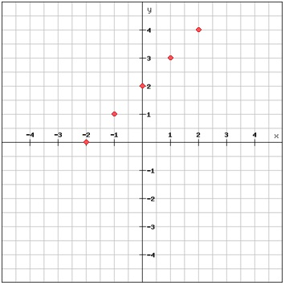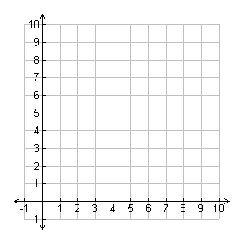

1. b.)

NOW – NEXT equation: NEXT = ____________ NOW – NEXT equation: NEXT = ___________

INPUT-OUTPUT equation: OUTPUT = ___________ INPUT-OUTPUT equation: OUTPUT = ________

**5.)** Find the first five terms for each recursive sequence.

1. START = -2 b. START = 1

NEXT = NOW +7 NEXT = NOW*3

____, ____, ____, ____, ____ ____, ____, ____, ____, ____

**6.)** Fill in the tables below for each INPUT-OUTPUT rule. Then write the rule using *x* and *y*.

a.) OUTPUT = INPUT*7 + -2 b.) OUTPUT = INPUT*2 + 4

|  |  |
| --- | --- |
| INPUT | OUTPUT |
| 0 |  |
| 1 |  |
| 2 |  |
| 3 |  |
| 4 |  |

|  |  |
| --- | --- |
| INPUT | OUTPUT |
| 0 |  |
| 1 |  |
| 2 |  |
| 3 |  |
| 4 |  |

Rule: ________________ Rule: ________________

Unit 3 Day 3 Homework: Functions (Skill 8 & 10)

**Use the described pattern to find the first 5 terms of the number sequence. Then write a NOW-NEXT or INPUT-OUTPUT equation for each.**

1. Each term of the sequence is found by adding 5 to the preceding term. The starting number is 3.

|  |  |  |  |  |  |
| --- | --- | --- | --- | --- | --- |
| Term | 1 | 2 | 3 | 4 | 5 |
| Number |  |  |  |  |  |

Write a recursive equation: _______________________

1. Each term of the sequence is found by multiplying the term by 7 and adding 3 to the result. The starting number is 80.

|  |  |  |  |  |  |
| --- | --- | --- | --- | --- | --- |
| Term | 1 | 2 | 3 | 4 | 5 |
| Number |  |  |  |  |  |

Write an explicit equation: _______________________

**Evaluate the following functions:**

**9. a. )** *f*(*x*) = *x*– 5 f(3) = ______ **b. )** *f*(*x*) = 2*x*2 – *x* + 10 f(-4) = _______

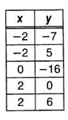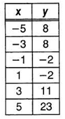**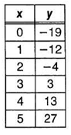10.) Are the following relations functions? If no, explain why.**

**a.) b.) c.)**

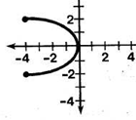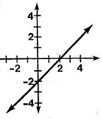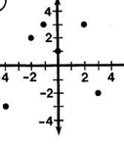**d.) e.) f.)**

Unit 3 Day 4 Homework: Domain and Range (Skill 8 & 10)

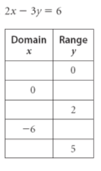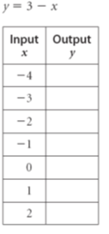**11.** With the given values, find the missing input (domain) or output (range).

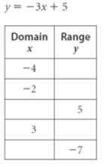a.) b.) c.)

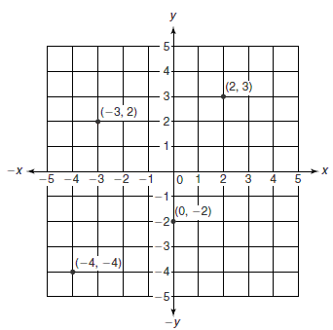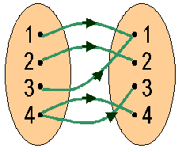**12.** Are the following functions? If yes, state the domain and range.

|  |  |
| --- | --- |
| **x** | **y** |
| 1 | 3 |
| 0 | 5 |
| -1 | 3 |
| -2 | 1 |

a.) b.) c.)

**13.** Use the graph of $y=f(x)$ at the right to answer each question.

1. What is the value of $f\left(4\right)$? _______________
2. What is the value of $f(6)$? _______________
3. For what value(s) does $f\left(x\right)=2$? _________________
4. For what value(s) does $f\left(x\right)=0$? _________________
5. For what *x*-values is $f(x)$ greater than 2? ______________
6. What are the domain and range shown on the graph?

Unit 3 Day 5 Homework: Average Rate of Change (Skill 9 & 10)

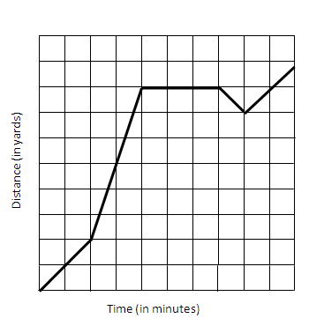The graph below represents the distance of the ball in an American football game. Fill in the table and answer the questions using the graph.

|  |  |
| --- | --- |
| $$t$$ | $$d(t)$$ |
| 0 |  |
| 1 |  |
| 2 |  |
| 3 |  |
| 4 |  |
| 5 |  |
| 6 |  |

1. What is the independent variable and the dependent variable?
2. How far did the ball travel from 0 to 2 seconds? What is the average rate of change (distance traveled per minute) for the first two seconds?
3. How far did the ball travel from 2 to 4 seconds? What is the average rate of change (distance traveled per minute) for these two seconds?
4. Is the ball travelling faster during the first 2 seconds or the next 2 seconds? How can you tell? How is this revealed in the graph?
5. When is the ball not moving forward down the field?
6. Where is the graph decreasing? Do you know what happens in football when the ball loses distance?